The Scottish Research Interest Groups (RIGs), comprising scientists, clinicians and people with Parkinson’s Disease and their families, are delighted to announce an in-person public lecture by:

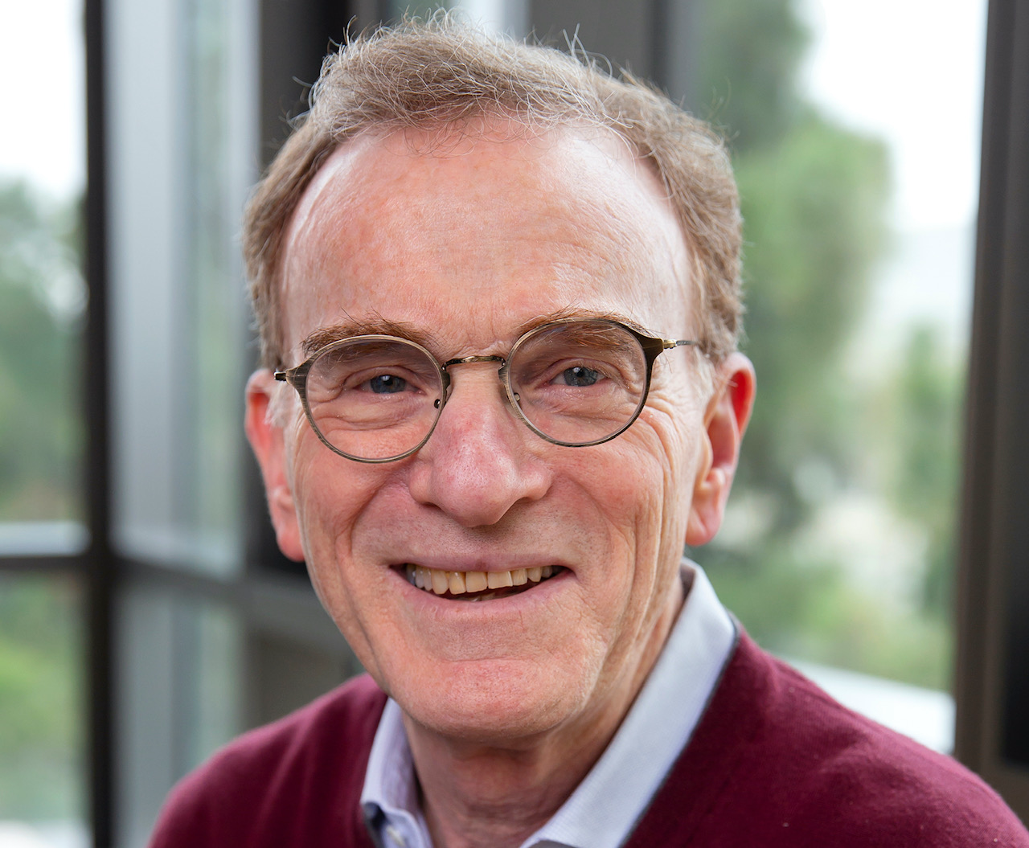

Nobel Laureate Professor Randy Schekman

Lecture: “Parkinson’s Disease, up close and personal”

Venue: Royal College of Physicians of Edinburgh, 1 Queen St, Edinburgh EH2 1JQ

Time: 3pm Saturday June 11, 2022

Programme:

3:00pm – Doors open

3:30pm – Welcome and introduction (Zoom live streaming commences)

3:45pm – Lecture by Professor Randy Schekman

4:30pm – Comfort break and informal exchanges

4:55pm – Questions, including virtual ones, and answers

5:40pm – Close

Professor Randy Schekman will start his lecture with a personal story, and then give a presentation on the evolution and structure of Aligning Science Across Parkinson’s Disease (ASAP), an international effort to identify and support basic research on the mechanisms of Parkinson’s Disease initiation and progression (https://parkinsonsroadmap.org).

Biography:

Dr Randy Schekman is a Professor in the Department of Molecular and Cell Biology, University of California, Berkeley, and an Investigator of the Howard Hughes Medical Institute. He studied the enzymology of DNA replication as a graduate student with Arthur Kornberg at Stanford University. His current interest in cellular membranes developed during a postdoctoral period with S. J. Singer at the University of California, San Diego. Among his awards are the Gairdner International Award, the Albert Lasker Award in Basic Medical Research and the Nobel Prize in Physiology or Medicine, which he shared with James Rothman and Thomas Südhof.

He is a member of the National Academy of Sciences, the National Academy of Medicine, the American Academy of Arts and Sciences, the American Philosophical Society, a Foreign Associate of the Accademia Nazionale dei Lincei, a Foreign Associate of the Royal Society of London and an Honorary Academician of the Academia Sinica. In 1999, he was elected President of the American Society for Cell Biology. From 2002-2017, he served as Editor-in-Chief of the Annual Reviews of Cell and Developmental Biology. From 2006 - 2011 he served as Editor-in-Chief of the Proceedings of the NAS. In 2011, he founded and until 2019 served as the Editor-in-Chief of the Open Access journal, eLife, sponsored by the HHMI, Wellcome Trust and the Max Planck Society. Beginning in 2019, Schekman became the scientific director of ASAP.

